Topic as per syllabus | As per Text Book
Synchronization: Background, Critical Section Problem, Mutex locks,  Semaphores, Classic Problems of Synchronization | Chapter 5 Process Synchronization  5.1 Background  5.2 The Critical-Section Problem  5.5 Mutex Locks  5.6 Semaphores  5.7 Classic Problems of Synchronization
Deadlocks: System Model, Deadlock characterization, Methods for handling  deadlocks, Deadlock prevention, Deadlock avoidance, Deadlock Detection  and Recovery from deadlock | Chapter 7 Deadlocks  7.1 System Model 315  7.2 Deadlock Characterization 317  7.3 Methods for Handling Deadlocks 322  7.4 Deadlock Prevention 323  7.5 Deadlock Avoidance 327  7.6 Deadlock Detection 333  7.7 Recovery from Deadlock 337

5.1

Introduction:
Synchronization in operating systems refers to the coordination of concurrent processes or threads to ensure that shared resources are accessed and modified in a consistent and orderly manner. In modern systems, which often involve multitasking and multithreading, processes frequently interact and share data or resources, making synchronization essential for maintaining system reliability and optimizing performance.
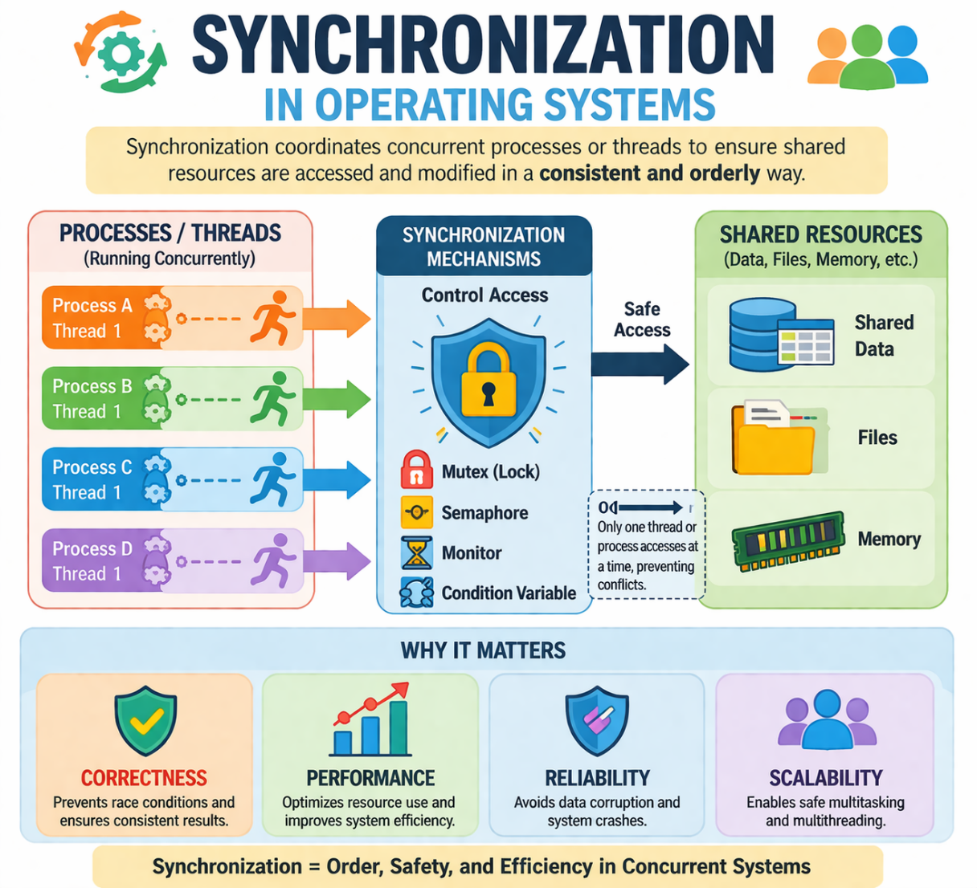

Importance of Synchronization
In a multitasking environment, processes or threads may execute simultaneously, leading to potential conflicts when accessing shared resources. Synchronization ensures:

Data Consistency:
Prevents data corruption and inconsistencies by regulating access to shared resources.

Mutual Exclusion:
Ensures that only one process can access a critical section of code at a time.

Coordination:
Allows processes to work together efficiently, avoiding deadlocks and race conditions.

Fairness:
Prevents indefinite blocking or starvation of any process while accessing shared resources.

Challenges in Synchronization
- Race Conditions:
Occur when the outcome of a computation depends on the timing or sequence of execution of processes.

Deadlocks:
Arise when two or more processes are stuck, each waiting for the other to release a resource.

Starvation:
Happens when a process waits indefinitely due to lack of resource access, often caused by priority issues.

Priority Inversion:
Occurs when a higher-priority process is waiting for a lower-priority process holding a resource.

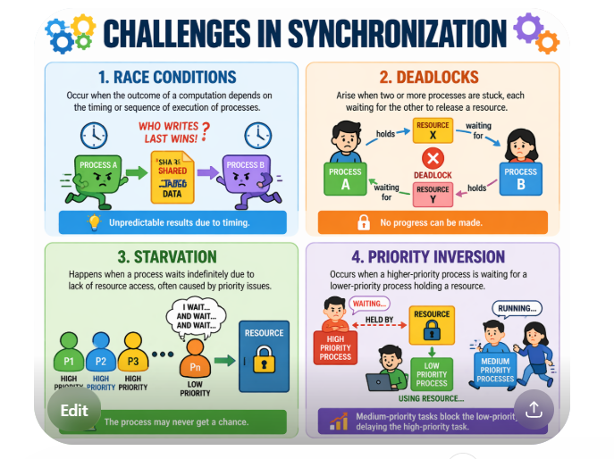

Examples 1 for race around Condition
- Processes P₀ and P₁ are creating child processes using the fork() system call

Race condition on kernel variable next_available_pid which represents the next available process identifier (pid)

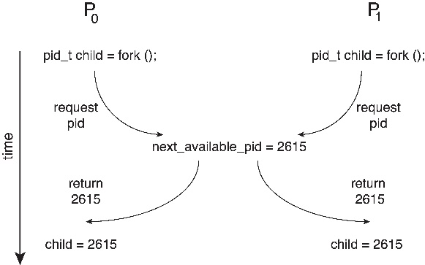

Unless there is a mechanism to prevent P₀ and P₁ from accessing the variable next_available_pid the same pid could be assigned to two different processes

Example 2 for race around Condition

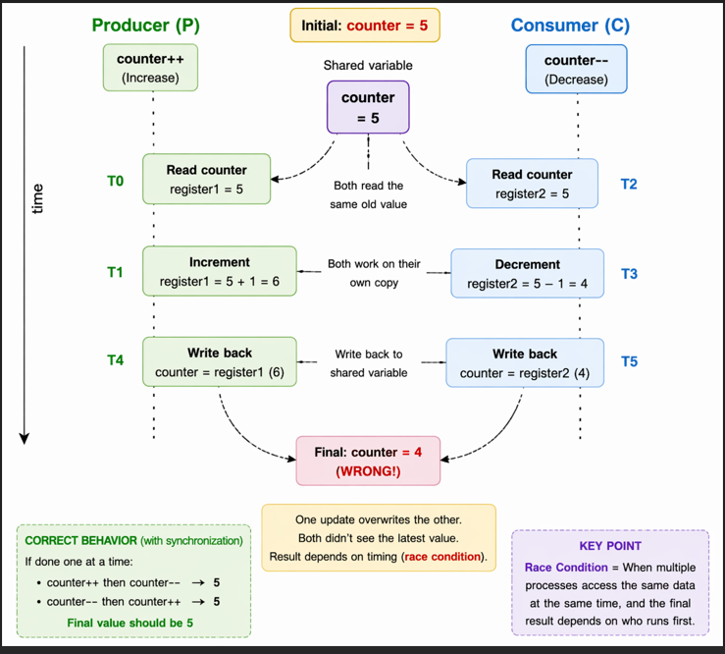

Synchronization Mechanisms
Operating systems use several mechanisms to manage synchronization effectively:

Locks and Mutexes:
Used to ensure mutual exclusion by allowing only one thread or process to access a critical section at a time.

Semaphores:
Counting variables that help manage access to limited resources by multiple processes.

Monitors:
High-level constructs combining mutual exclusion and condition variables for process coordination.

Message Passing:
Enables processes to synchronize by communicating through messages rather than shared memory.

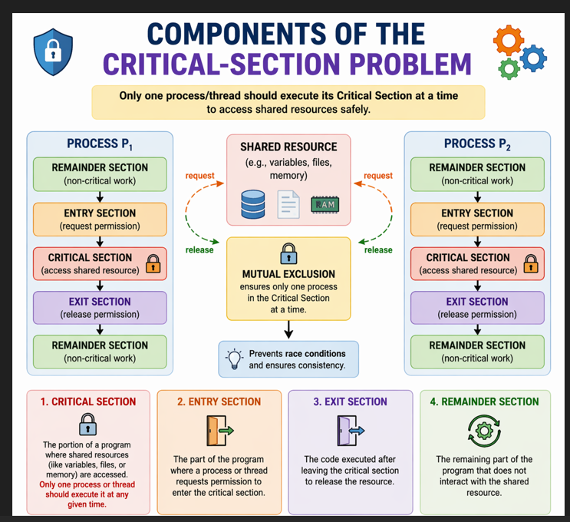
Real-World Relevance
Synchronization is vital for applications like databases, operating systems, and multi-user environments, where concurrent processes must maintain data integrity while working together. Understanding synchronization ensures efficient system design and helps resolve challenges in concurrent programming.

The Critical-Section Problem:

The Critical-Section Problem is a fundamental concept in operating systems and concurrent programming. It arises when multiple processes or threads need to access shared resources or data simultaneously, requiring mechanisms to ensure consistency and prevent conflicts. Synchronization techniques are used to solve this problem by controlling access to shared resources.
Critical Section = “Where problem occurs”
Synchronization = “Strategy How problem is solved”

Components of the Critical-Section Problem
    - Critical Section:
The portion of a program where shared resources (like variables, files, or memory) are accessed. Only one process or thread should execute its critical section at any given time.

Entry Section:
The part of the program where a process or thread requests permission to enter the critical section.

Exit Section:
The code executed after leaving the critical section to release the resource.

Remainder Section:
The remaining part of the program that does not interact with the shared resource.

Requirements for a Solution
To solve the critical-section problem, any synchronization solution must satisfy these conditions:

Mutual Exclusion:
Only one process can execute in the critical section at a time.

Progress:
If no process is in the critical section, other processes waiting to enter must be allowed to do so without indefinite delay.

Bounded Waiting:
A process attempting to enter the critical section should not wait indefinitely. There must be a bound on how many other processes can access the critical section before it is granted access.

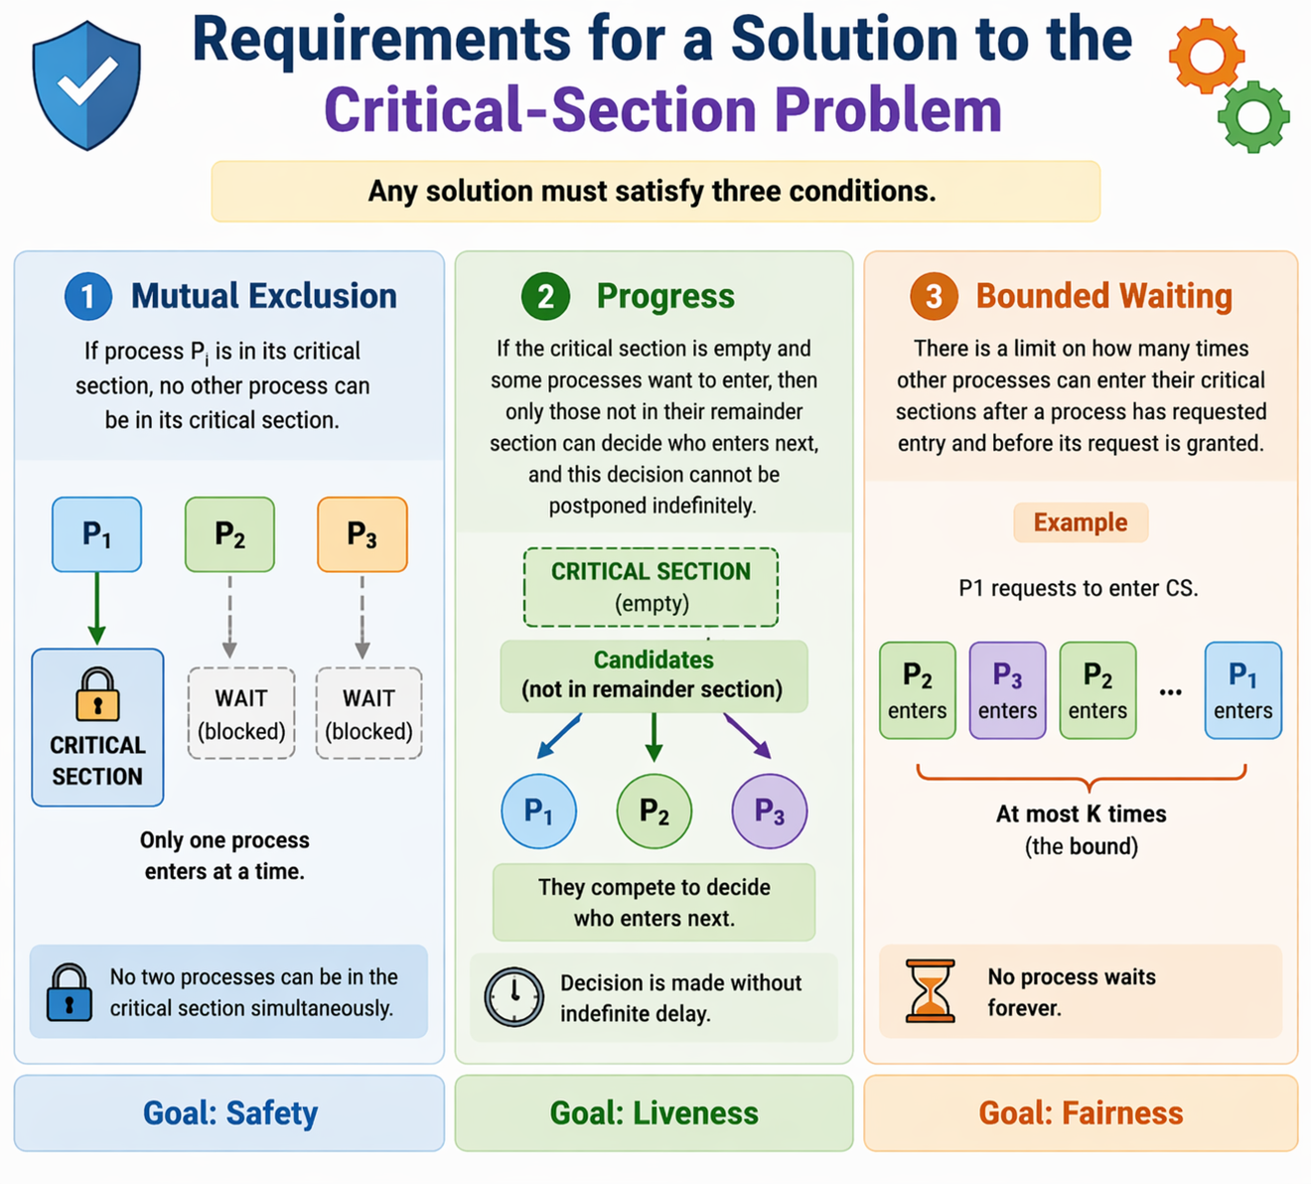

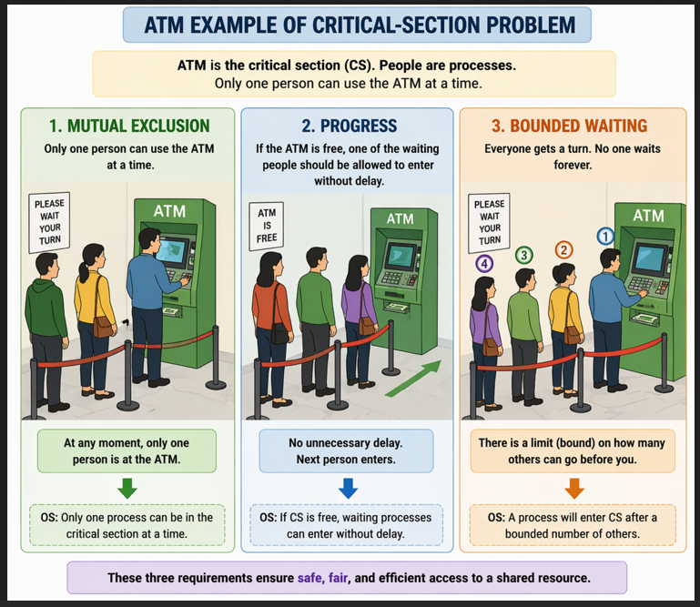

  - Mutex Locks

Introduction
Hardware-based solutions to the critical-section problem are often complex and not directly accessible to application programmers. Therefore, operating system designers provide software tools to solve the critical-section problem. One of the simplest synchronization tools is the Mutex Lock.

What is a Mutex Lock?
- Mutex stands for Mutual Exclusion.
- It is used to protect critical sections and prevent race conditions.
- Only one process or thread can execute inside the critical section at a time.
- A process must acquire the lock before entering the critical section.
- The process releases the lock after exiting the critical section.

Working of Mutex Lock
Function | Purpose
acquire() | Obtains the lock before entering the critical section.
release() | Releases the lock after leaving the critical section.

Boolean Variable Used
Mutex lock uses a boolean variable called 'available' to indicate whether the lock is free or occupied.
Value of available | Meaning
true | Lock is available
false | Lock is unavailable

Pseudo Code for acquire() Function
acquire() {
while (!available)
; /* busy waiting */
available = false;
}

Pseudo Code for release() Function
release() {
available = true;
}

Process Execution using Mutex Lock
do {
acquire lock
critical section
release lock
remainder section
} while (true);

Important Concepts
- Busy Waiting: A process continuously checks the lock until it becomes available.
- Critical Section: Part of the program where shared resources are accessed.
- Race Condition: Occurs when multiple processes access shared data simultaneously.
- Mutual Exclusion: Ensures only one process executes in the critical section at a time.

Advantages of Mutex Locks
- Simple and easy to implement.
- Provides mutual exclusion effectively.
- Prevents race conditions.

Disadvantages of Mutex Locks
- Busy waiting wastes CPU time.
- Can lead to starvation in some cases.
- Not efficient for long waiting periods.

  - Semaphores
Semaphores:
A semaphore is an integer synchronization variable accessed through atomic operations wait() and signal(), where wait() decrements the value when resources are available and blocks otherwise, and signal() increments the value to release a resource.
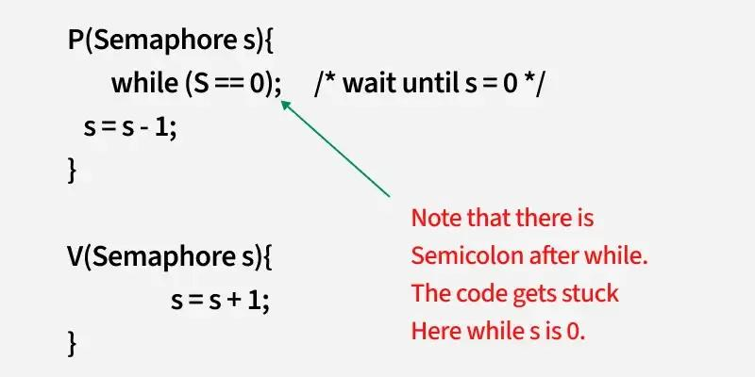

Semaphores are widely used to address synchronization problems without the need for busy waiting. In addition, operating systems offer various synchronization mechanisms such as semaphores, mutexes, and condition variables to control access to shared data. In transaction management, ensuring atomicity and serializability is crucial, often accomplished through techniques like write-ahead logs, undo/redo operations, and concurrency-control schemes.
A semaphore is a synchronization primitive used to control access to shared resources in a concurrent system. It is a variable or abstract data type that is manipulated using two atomic operations: wait (P) and signal (V).
- Wait (P): This operation decreases the value of the semaphore. If the value becomes negative, the process is blocked until the semaphore is positive again.
- Signal (V): This operation increases the value of the semaphore, potentially unblocking a waiting process.

Types of Semaphores:
  - Binary Semaphore (Mutex): Takes only values 0 or 1, used for mutual exclusion.
  - Counting Semaphore: Used for controlling access to a resource pool, with a range of values beyond just 0 or 1.

Example:
Consider two processes trying to access a shared resource: semaphore mutex = 1; // Initially, the semaphore is available (1).

void process() {
wait(mutex); // Enter critical section (decrement semaphore)
// Access shared resource
signal(mutex); // Leave critical section (increment semaphore)
}
In this example, only one process can access the critical section at a time. If the semaphore is 0, other processes must wait until it becomes positive.
Types of Semaphores
Binary Semaphore (0 or 1)

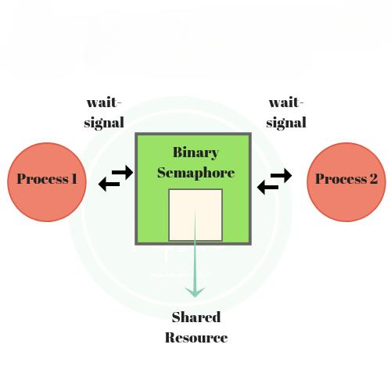

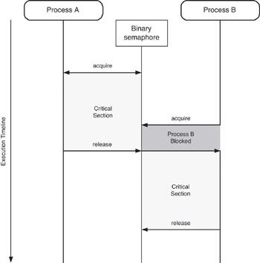

Value = 0 or 1
👉 Works like mutex
✔ Used for mutual exclusion
✔ Only one process enters
Counting Semaphore (0,1,2,...)
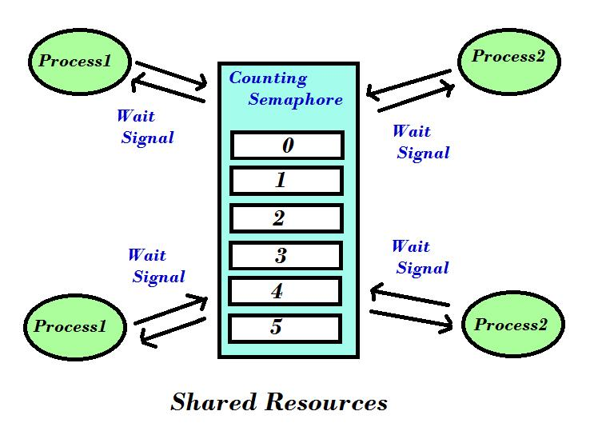

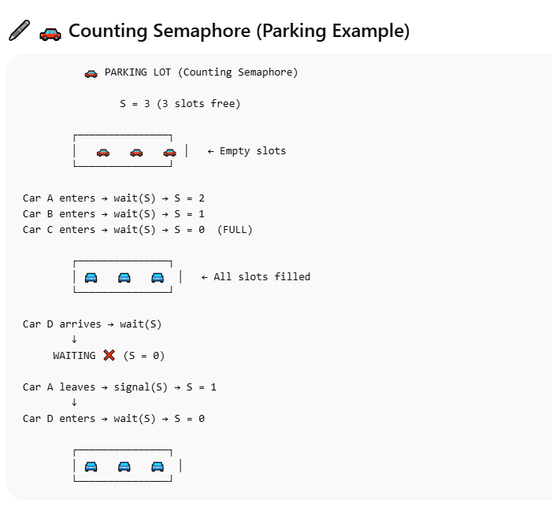

Usage
      - Counting Semaphores: These semaphores can take any non-negative integer value and are used to manage a resource pool with a finite number of instances. Example: If a printer pool has 3 printers, the semaphore is initialized to 3.

      - Binary Semaphores (Mutex Locks): These have values of either 0 or 1, used to enforce mutual exclusion, ensuring only one process enters the critical section at a time. Example: A process can enter a critical section only if mutex = 1. After entering, it sets mutex = 0 to block others.
      - Critical Section Control with Binary Semaphores: Multiple processes share a binary semaphore (mutex) initialized to 1. Each process calls wait(mutex) before entering its critical section and signal(mutex) when leaving, ensuring mutual exclusion.
      - Resource Management with Counting Semaphores: Counting semaphores control access to a limited number of resources. If the semaphore value is greater than 0, a process can decrement it (use a resource); if 0, processes block until a resource is freed. Example: A system with 5 printers uses a counting semaphore initialized to 5.
      - Semaphore Example for Synchronization: Suppose process P1 executes S1 and process P2 executes S2, where S2 should only execute after S1. This can be achieved by using a shared semaphore synch, initialized to 0.

Synchronization using Semaphores:
        - Process P1 executes S1 and then signals synch with signal(synch).
        - Process P2 waits on the semaphore with wait(synch) before executing S2. This ensures that P2 runs S2 only after P1 has completed S1.
      - Blocking with Counting Semaphores: When a process tries to use a resource but the semaphore value is 0, it blocks until the resource becomes available. For example, a resource with 3 available units would block processes trying to access it once the semaphore reaches 0.

Semaphore Operations:
        - Wait(): Decrements the semaphore value. If the value is 0, the process is blocked.
        - Signal(): Increments the semaphore value, potentially waking up a blocked process.
      - Mutex for Mutual Exclusion: Binary semaphores (mutexes) are commonly used to protect critical sections in multi-threaded environments, ensuring that only one thread can access shared resources at a time.
      - Semaphore Use in Producer-Consumer Problem: In a producer-consumer system, a counting semaphore can be used to track the number of available slots in a buffer, ensuring that producers don’t overwrite the buffer and consumers don’t attempt to consume from an empty buffer.

Implementation

Types of Semaphore Implementation
👉 There are two types:
- ❌ Busy Waiting (Spin)
- ✅ Blocking (No Busy Waiting)

1. ❌ Busy Waiting (Spin)
S is the semaphore variable
It is an integer value that represents: S is the semaphore variable
It is an integer value that represents: Number of available resources OR permission to enter
wait(S) {
while (S <= 0)
; // busy wait (spin)
S--;
}
signal(S) {
S++;
}
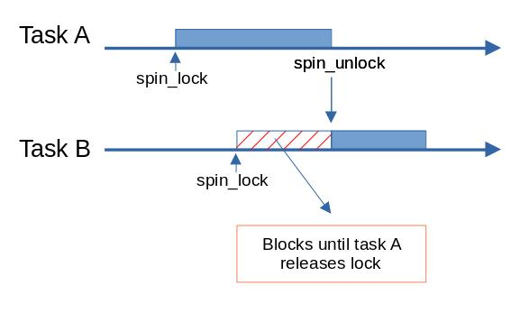
- Blocking (No Busy Waiting)
Busy waiting wastes CPU cycles as processes continuously check the semaphore, whereas blocking implementation suspends processes and maintains a waiting queue, improving CPU utilization while ensuring atomic execution of wait() and signal().”

wait(S) {
S--; // decrease resource count
if (S < 0) {
add this process to queue;
block(); // go to sleep (no CPU usage)
}
}

signal(S) {
S++; // increase resource count
if (S <= 0) {
remove a process P from queue;
wakeup(P); // wake up one waiting process
}
}
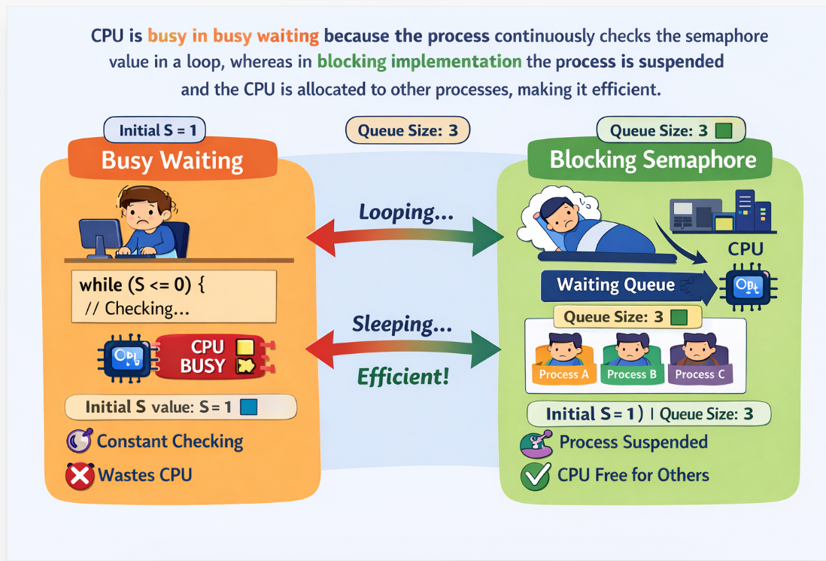

The main disadvantage of semaphores is the need for busy waiting, where a process continuously checks if it can enter the critical section. This wastes CPU cycles that could be used by other processes. In systems with a single CPU, busy waiting can be inefficient. Spinlocks, a type of semaphore, avoid context switches by "spinning"

5.6.3 Deadlocks and Starvation

A deadlock occurs when two or more processes are blocked indefinitely, each waiting for a resource held by another. In this situation, no process can proceed, resulting in a "circular wait."
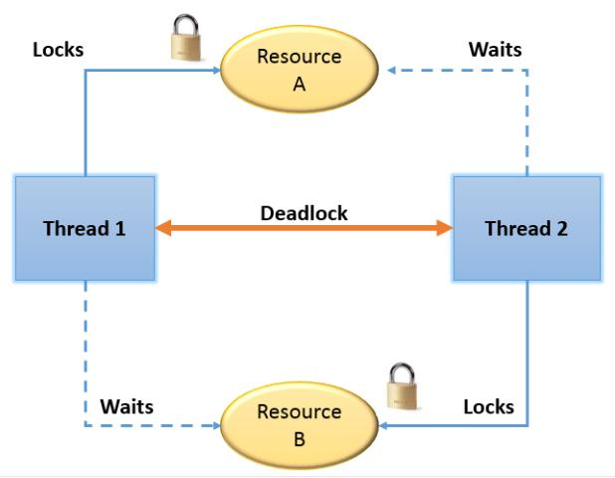

Example of Deadlock:
Consider two processes, P1 and P2, each needing two semaphores to complete their tasks. If P1 acquires semaphore1 and waits for semaphore2, and P2 acquires semaphore2 and waits for semaphore1, a deadlock occurs because both processes are stuck, each waiting for the semaphore held by the other.
sem_t semaphore1, semaphore2;

void* process1(void* arg) { sem_wait(&semaphore1); // Acquires semaphore1
sem_wait(&semaphore2); // Waits for semaphore2 (Deadlock)
// Critical section
}

void* process2(void* arg) { sem_wait(&semaphore2); // Acquires semaphore2
sem_wait(&semaphore1); // Waits for semaphore1 (Deadlock)
// Critical section
}

while waiting for a lock. However, they are only useful for short lock durations. To overcome busy waiting, we can modify the wait() and signal() operations to block processes when the semaphore value is negative, adding them to a waiting list. A process is awakened when a signal() operation occurs. This blocking method, which avoids busy waiting, helps in better managing system resources and CPU time. A semaphore can be defined as a structure containing a value and a process list. While this reduces CPU waste, care must be taken to ensure atomic execution of wait() and signal() operations to avoid race conditions..

Starvation
Starvation occurs when a process is continually denied access to a resource because other processes keep taking the resources first. This is often caused by unfair scheduling or prioritization.

Example of Starvation:
In a system where a high-priority process continuously acquires the semaphore before a low-priority process, the low-priority process may never get a chance to execute.
5.6.4 Priority Inversion

sem_t semaphore;

void* high_priority_process(void* arg) { sem_wait(&semaphore); // Acquires semaphore
// Executes sem_post(&semaphore);
}

void* low_priority_process(void* arg) {
sem_wait(&semaphore); // Waits for semaphore (Starvation risk)
// Executes sem_post(&semaphore);
}
Here, the high-priority process might always acquire the semaphore first, leading to starvation for the low-priority process.

Time | Event | Running Process | State of Others | Explanation
T0 | Start | L | M: Not ready, H: Not arrived | L starts and acquires resource R
T1 | H arrives | L | H: Waiting, M: Not ready | H needs R → blocked (waiting)
T2 | M arrives | M | L: Ready, H: Waiting | M has higher priority → preempts L
T3 | Execution | M | L: Ready, H: Waiting | M keeps running
T4 | Still blocked | M | L: Ready, H: Waiting | L not running → cannot release R
T5 | Result | — | H still waiting ❌ | Priority Inversion occurs

L holds resource → H waits → M runs → H delayed

Time | Event | Running Process | State of Others | Explanation
T0 | Start | L | M: Not ready, H: Not arrived | L acquires resource R
T1 | H arrives | L (becomes High) | H: Waiting | L inherits H’s priority
T2 | M arrives | L | M: Ready, H: Waiting | M cannot preempt L now
T3 | Execution | L | M: Ready, H: Waiting | L continues execution
T4 | Release | L | H: Ready | L releases resource R
T5 | Final | H | M: Ready | H gets R and executes

- Deadlock: A situation where processes wait indefinitely for resources, creating a circular dependency.
- Starvation: A situation where a process is perpetually denied resources due to unfair scheduling or resource allocation.
In both cases, the correct use of semaphores and careful scheduling policies can help prevent these issues. For example, avoiding circular waits can prevent deadlocks, while fair scheduling algorithms can mitigate starvation.

